Neural Network computing technique is one of the most accurate and widely used forecasting models. Models based on it are data-driven and have self-adaptive methods with few prior assumptions. They are especially efficient in solving nonlinear problems. This contrasts with many traditional techniques for time series predictions, such as ARIMA, which by design assumes series to be generated from linear processes and as a result might be inappropriate for most real-world problems such as stock market's uncertain behavior that changes with time.

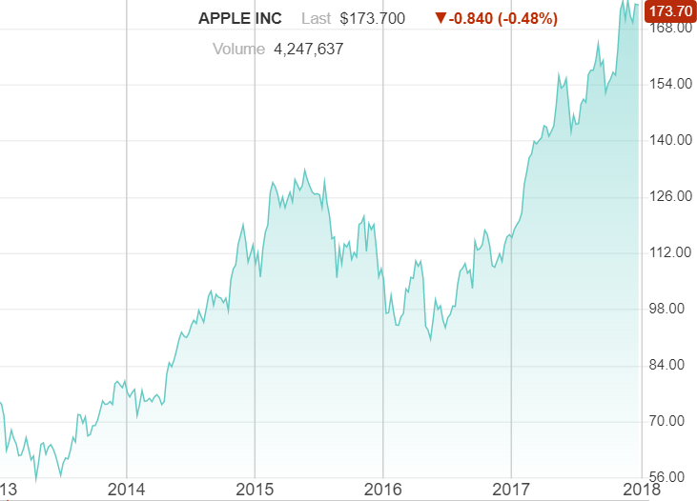

The R based Power BI visual ‘Forecast using Neural Network’ developed by MAQ Software allows user to forecast future values based on the historical data. Unlike some of the other forecasting techniques, the visual will work for both numerical series i.e. years/numbers and proper Date/Time values. Let’s see the visual demo. Here we have taken the case of gold price over the years and using the visual we will try to predict the price. As you can see, we have dataset containing global prices for gold averaged for a year from 1975 to the year 2015. ~~We are going to use the visual.~~ On ‘Field’ pane we provide data we are interested in. In this case we are going to provide year and gold price. So, let’s select year and gold price to get the data. Visual takes some time to load and present, as it will calculate and process the data using algorithm in mean time. Here it comes. We can see that yellow portion is the predicted values of gold prices for upcoming years that is year 2016 and onwards.

Let’s see how we can customize and smoothen the chart as per our requirements. For that lets go to formatting pane. Forecast setting allows certain configurations. Though for easiness of user, the algorithm will automatically get designed but if in case someone wants to technically configure the visual they can choose to have user defined parameters. These parameters include

* Decay rate, which will Induce decay in weights with depth. Meaning it will reduce the learning rate of algorithm
* Maximum number of iterations to train the algorithm
* Units, the number of units up to which next value will be predicted. Here the visual will predict till next 10 years.
* Epoch, refers to performance of iteration at regular frequency. For example, if epoch is 20 and iteration is 150, this mean that we (redo or make) all 150 iterations over and over 20 times.
* Size, defines number of calculation performed to achieve output equation for the model in each iteration.

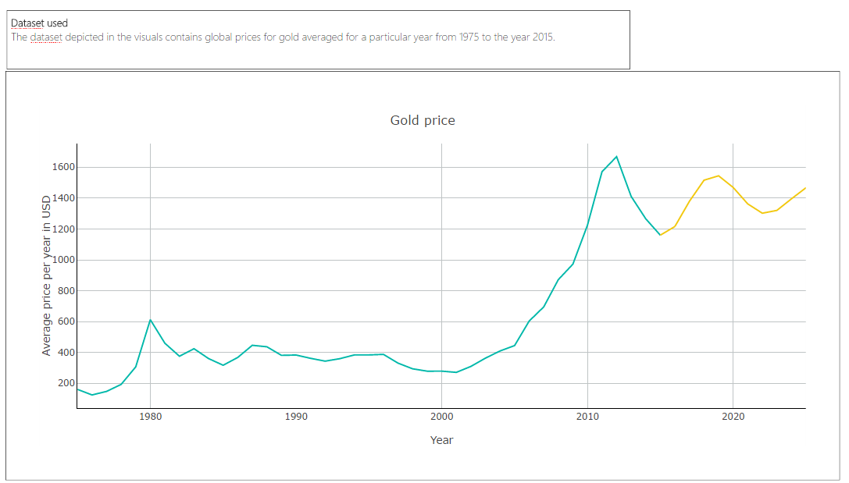

Now, I also want to know the ranges of Gold price instead of getting exact predicted value. In this case confidence level needs to be On. So, I am turning it On, lets see how it comes up. ~~Though it will take some time to regenerate the whole graph.~~ Here it comes. The shadow region along the forecasted line shows the range in which value may fall. This range may vary depending on the confidence level. So, if I chose 0.8 it will increase and for 0.5 it will decrease.

There are other settings which would be helpful in labelling and coloring of the component of chart like axis labelling, line chart color etc.

Another thing to note is the availability of various options to visualize this chart, if I want to see the gold prices precisely for a year or in between on-line chart I can zoom in. Also, I can download the image of the chart. It also provides tooltips on hover and highlighting a portion of the plot.

The visual is dependent on R packages like Forecast, plotly, zoo, xts which will be auto-installed at the time of loading.